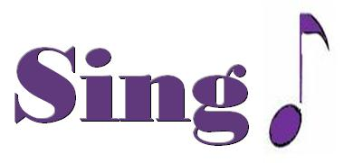
Proud – Heather Small

I look into the window of my mind
Reflections of the fears I know I've left behind
I step out of the ordinary
I can feel my soul ascending
I'm on my way
Can't stop me now
And you can do the same (yeah)
What have you done today to make you feel proud?
It's never too late to try
What have you done today to make you feel proud?
You could be so many people
If you make that break for freedom
What have you done today to make you feel proud?
Still so many answers I don't know (there are so many answers)
Realize that to question is how we grow (to question is to grow)
So I step out of the ordinary
I can feel my soul ascending
I'm on my way
Can't stop me now
You can do the same (yeah)
What have you done today to make you feel proud?
It's never too late to try
What have you done today to make you feel proud?
You could be so many people
If you make that break for freedom
What have you done today to make you feel proud?
(yeah) We need a change (Yeah)
Do it today (yeah)
I can feel my spirit rising
(change, yeah) We need a change (yeah)
So do it today (yeah)
'Cause I can see a clear horizon
What have you done today to make you feel proud? (to make you feel proud)
(let me hear ya X3)So what have you done today to make you feel proud?
(yeah)'Cause you could be so many people
Just make that break for freedom
So what have you done today to make you feel proud?

